Accelerometru si Giroscop

Componente:

* 1 \* Raspberry Pi (Raspberry Pi Model 3 B+
* 1 \* Breadboard

<https://www.optimusdigital.ro/ro/prototipare-breadboard-uri/8-breadboard-830-points.html>

* 1 \* Modul Accelerometru și Giroscop cu 3 Axe MPU6050

<https://www.optimusdigital.ro/ro/senzori-senzori-inertiali/96-modul-senzor-triaxial-mpu-6050.html>

Circuit:

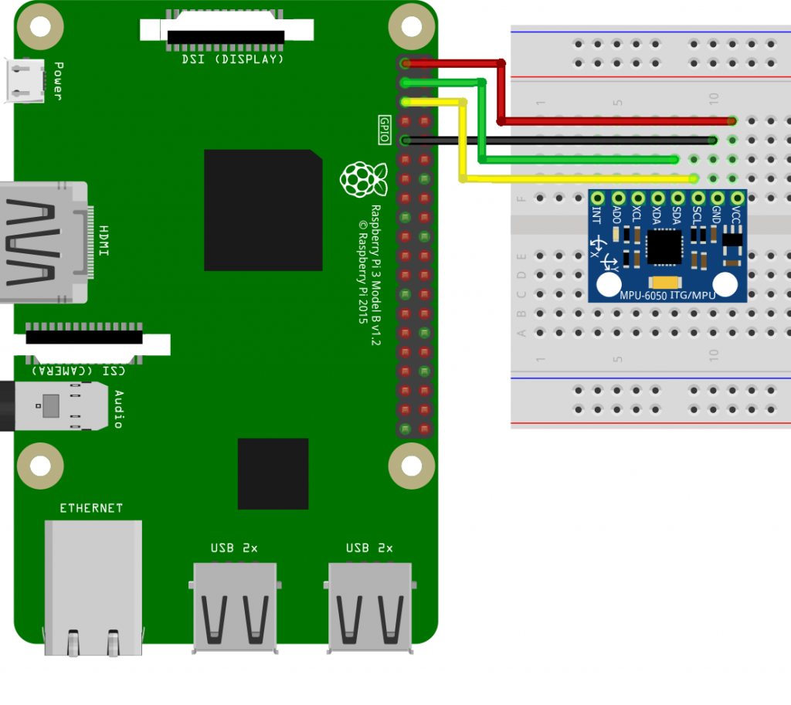

C code:

<https://github.com/srgian/internship_1903/blob/master/giroscop/MPU6050-Pi-Demo/MPU6050.cpp>